Demand Analysis -- Siyu Chen

1. Aggregated Demand per 15 minutes

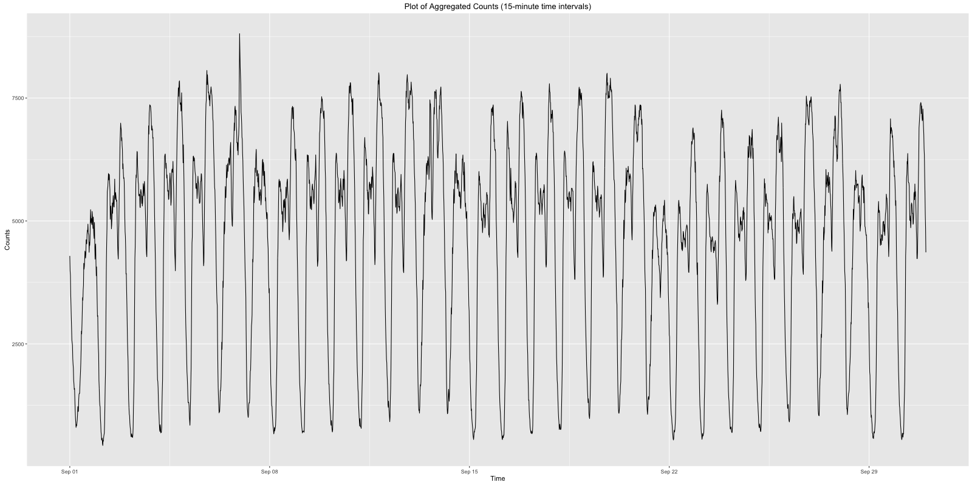

Fig 1.1 Aggregated counts of Taxi

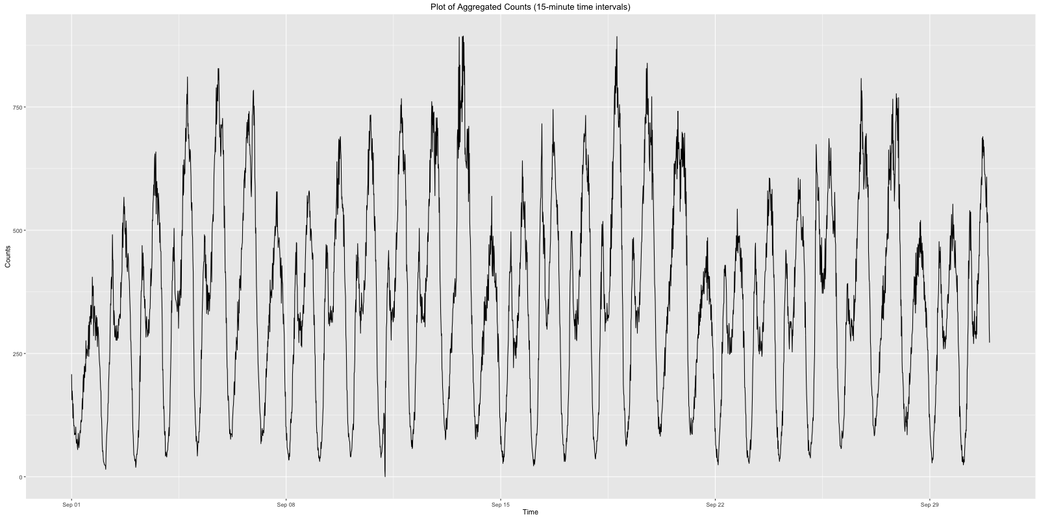

Fig 1.2 Aggregated counts of Uber

Results got from the plots:

1. Basically, demand of taxi is ten times greater than that of Uber.

2. However, we can see there exist some time points where both demands of taxi and uber are very low. Generally, it is from midnight to early morning when most people are still sleeping.

2. Weekly demand analysis

In order to get more details of how demand changes in a week, we calculated the hourly demand and grouped them by weekdays.

Lines in different color represent how demand changes during a weekday and dots represent average demand in that day.

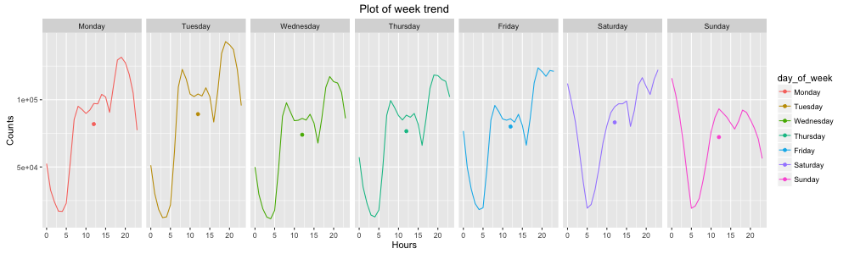

Fig 2.1 Weekly trend of Taxi

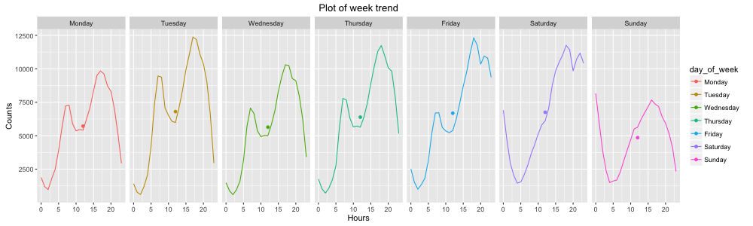

Fig 2.2 Weekly trend of Uber

These two plots verified our previous guess that the low demand appeared after midnight.

For taxi data, here’s one main peak period during a typical workday (from Monday to Thursday) from 19 to 21 when people are about going home from work. The secondary peak hour is from 7 to 9 in the morning when people are about going to work. These two peak periods on workdays can be seen more clearly and obviously in the plot of Uber demand.

The demand becomes slightly different in Friday. To be more precise, the discrepancy appears from Friday night. Here’s a relative low ebb at around 8 p.m. in both two plots, which didn’t appear in the plots of other workdays.

The demand for Saturday and Sunday are much different than other days. Both taxi and Uber data show that the demand remains high even after midnight and the secondary peak period in the morning disappeared. It makes sense since people would like to go out with friends to have a relax at Saturday night and most of them won’t weak up and go out early in weekends. The demand at night is still high on Saturday but for Sunday night, most people would rather stay at home and sleep early to prepare for the coming week.

3. Daily Demand Analysis

From previous weekly plots, we can apparently see the Sunday demand is less than other days. How about demand changing during the month?

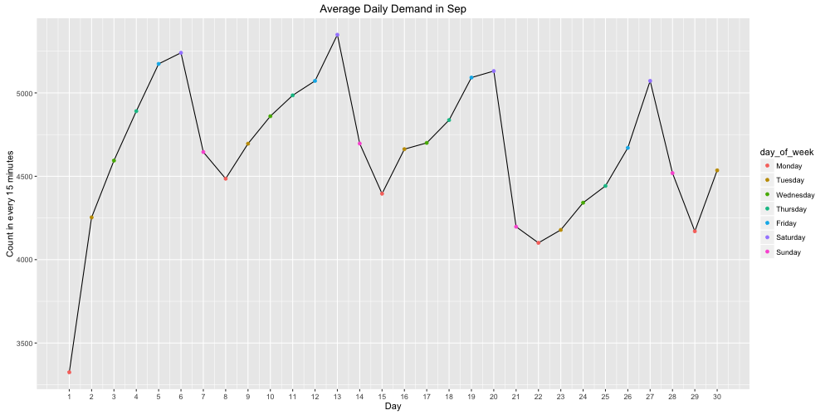

Fig 3.1 Daily trend of Taxi

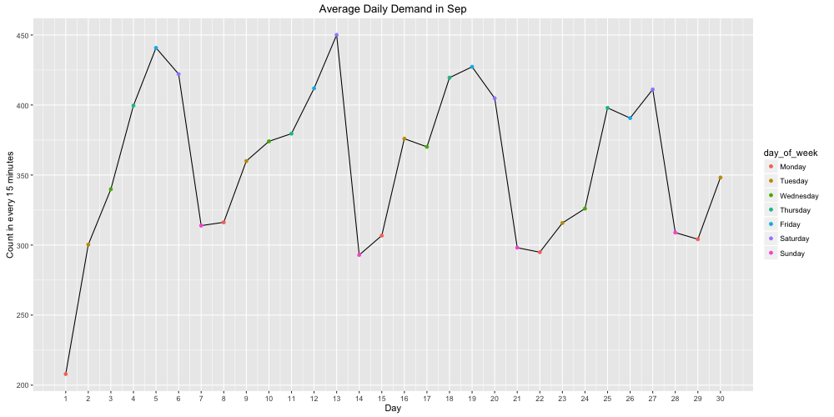

Fig 3.2 Daily trend of Uber

From two plots, we found demands on Monday and Sunday are much less than other days. And taxi data brings out a more stable period of demand changing: demand increased continually from Monday to Saturday and dropped from Saturday to Monday.